Managing Staff performance and staff development

Managing staff performance

Motivated and productive staff are key to the success of your agricultural or horticultural business, but this doesn’t happen by chance. Looking after your teams, working with them to meet their needs and understanding what motivates them is key to both retaining and enthusing everyone in the organisation. If you work alone, understanding what motivates you to improve is just as important.

Team members will often have different motivators, which can be broken down into nine areas;

(Motivational Mapping, Sale and Moynan)

Some people thrive on achievement, again with their own area of success defined. Expert relates to knowledge acquisition, builder relates to money and director is more about having influence over decisions made.

Team members motivated by relationships may be characterised by stars, who crave recognition, friends who like harmony within the team, and defenders who value long term stability and security.

Those motivated by growth may be searchers, who like to make a difference in the world, spirits, who like to be independent and make their own decisions, and creators who like innovative solutions within the workplace.

What is your key motivator?

How well do you know your team members? In agriculture, teams may not work in close quarters very often, being in their own tractor or looking after livestock, so understanding each other becomes vital for good co-operation.

Name three team members and think about what motivates them;

|  |  |  |
| --- | --- | --- |
| Team member name | Identified motivator | What can you do to motivate them? |
|  |  |  |
|  |  |  |
|  |  |  |

General motivators are summed up by Herzberg, who identified a series of Hygiene factors (which must be in place for people to feel secure at work), and motivating factors, which directly influence performance and attitude.

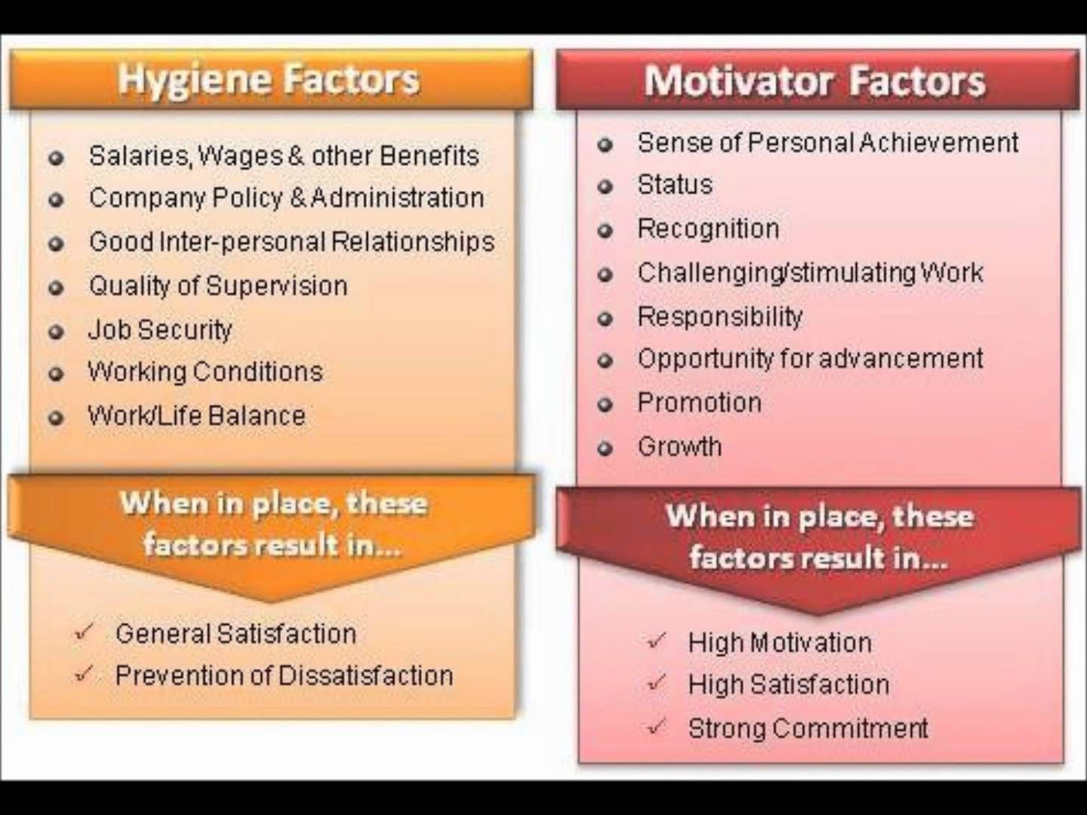

However, in any workplace there might be team members who are underperforming or demonstrating misconduct.

Underperformance might manifest as;

* Unacceptable standards of work
* Poor quality work
* Low productivity
* Poor output

Misconduct is characterised as;

* Lateness or repeated absences from work
* Poor attitude to work or colleagues
* Theft, fraud or sabotage of work property.

If Managers don’t address the problem;

Acceptable performance;



T

If nothing is said, the perceived level of acceptance drops (‘it must be alright because no one has said anything’)

This can very quickly become a slippery slope with standards dropping rapidly. Furthermore respect for you as a Manager is diminished, and it can be very difficult to re-instate the required standards.

So how do you recognise underperformance? How would you spot the problem in a team member? Name five signs that might alert you;

|  |
| --- |
| 1………………………………………………………………………………………………………………………………………….  2………………………………………………………………………………………………………………………………………….  3………………………………………………………………………………………………………………………………………….  4………………………………………………………………………………………………………………………………………….  5…………………………………………………………………………………………………………………………………………. |

Typical signs might be;

* Needing more management time and input
* Frequent unnecessary errors
* Time wasting, both of own time and that of other team members
* Missing deadlines
* Avoiding the less pleasant tasks and not doing their fair share of them
* Longer than allowed breaks or greater frequency
* Being argumentative

Before blaming your team member for their behaviour, stop and ask yourself some key questions;

* Have I made my expectations clear to them?
* Do they know precisely what is expected?
* Do they receive regular (at least once a month) feedback from me?
* Have they had sufficient training/development to carry out the work?
* Do I help team members keep their skills current?
* Are they confident and motivated?
* Is their workload too high?
* Do they have personal outside influences that stop them from performing as expected?
* Is lack of communication between me and my team member, customers or other colleagues preventing them from performing as required?
* Am I doing everything I can to recognise and reward contributions?
* Have I discussed with my team member what they feel the problem is

There tends to be four reasons for underperformance;

* Is the level of performance expected clear?
* Do they know they are underperforming?
* Are they able to perform as required (physically and mentally?)
* Are they wilfully not performing as required?

Clearly each scenario needs a different solution.

Think about each scenario and come up with three possible actions to resolve the situation;

|  |  |
| --- | --- |
| Scenario | Action |
| Is the level of performance expected clear? | 1………………………………………………………………………………..  2………………………………………………………………………………..  3……………………………………………………………………………….. |
| Do they know they are underperforming? | 1………………………………………………………………………………..  2………………………………………………………………………………..  3……………………………………………………………………………….. |
| Are they able to perform as required (physically and mentally?) | 1………………………………………………………………………………..  2………………………………………………………………………………..  3……………………………………………………………………………….. |
| Are they wilfully not performing as required? | 1………………………………………………………………………………..  2………………………………………………………………………………..  3……………………………………………………………………………….. |

Clarity of messaging is very important when dealing with these issues, and explaining WHY a certain behaviour is required should form part of your dialogue with the team member. However a certain sensitivity is also needed to support team members who may have a range of issues including struggling with their mental health.

Addressing underperformance requires formulation of an Action Plan, made in agreement with the team member.

Think of four things to be included on the plan;

|  |
| --- |
| 1………………………………………………………………………………………………………………………………………….  2………………………………………………………………………………………………………………………………………….  3………………………………………………………………………………………………………………………………………….  4…………………………………………………………………………………………………………………………………………. |

Firstly, some SMART objectives are needed, depending on what needs to be addressed. SMART means; Specific, Measurable, Achievable, Realistic and Time-bound. These must be agreed with the team member as Achievable and Realistic, but must also start to challenge the underperformance issue. Any support to be offered, such as training, mentoring or coaching should be detailed, and recorded as having happened.

Regular review meetings must be scheduled to monitor performance against the objectives. Further support should be offered at these meetings, and where possible, praise for effort and progress and encouragement for the future. Even when teams do not meet on a daily basis such meetings are very important. If working alone set yourselves some objectives for the day/week to ensure you maintain productivity levels.



As a Manager your role is to ensure;

* Everyone has SMART objectives
* There is good communication between team members, other teams and Management
* Workload is managed to ensure no-one is overwhelmed, and no-one is idle
* Provide constructive feedback regularly to both encourage good behaviour and intervene early where behaviours need to be changed
* Ensure there is ongoing development of team members so they feel valued and invested in
* Appreciation and gratitude are the bedrock of your management style (see Herzberg above!)
* There are clear actions which will be taken should performance issues persist.

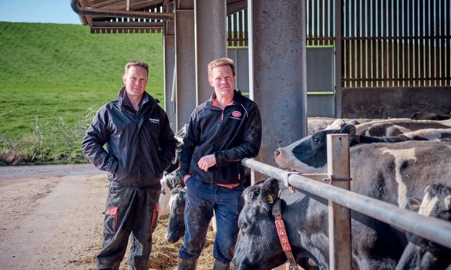

Disciplinary and Grievance procedures

Where poor performance does not change, it may be necessary to instigate performance management protocols, which may include disciplinary actions.

Your company will have a grievance and disciplinary procedure in place which has been designed to help resolve issues that may arise should a grievance come about.

Most complaints and grievances are best resolved informally with discussions with your supervisor or manager. However in some circumstances it may be necessary to resort to formal procedures. The grievance and disciplinary procedure will outline the correct action to take and state each action point.

Both supervisor/manager and employee should keep records of meetings whether they are informal or formal.

Policies are documents which give general guidance on how people should be treated, ensure you treat everyone in the same way, ensure you deal with issues fairly and reasonably and make sure your employer complies with the current law.

Procedures describe exactly how these policies are applied in practice, and they must be followed.

Disciplinaries happen where there are ongoing failures to meet standards, despite advice and guidance on how to improve.

Grievances are where an employee complains about the treatment they have received.

If you are a smaller organisation their might not be actual policies in place, but you should be able to speak to a senior person to try to resolve issues.

Describe your organisations disciplinary procedure;

|  |
| --- |
| …………………………………………...………………………………………………………  …………………………………………...………………………………………………………  …………………………………………...………………………………………………………  …………………………………………...………………………………………………………  …………………………………………...………………………………………………………  …………………………………………...……………………………………………………… |

Describe your organisations grievance procedure;

|  |
| --- |
| …………………………………………...………………………………………………………  …………………………………………...………………………………………………………  …………………………………………...………………………………………………………  …………………………………………...………………………………………………………  …………………………………………...………………………………………………………  …………………………………………...……………………………………………………… |

If you have a grievance what action would you take?

|  |
| --- |
| …………………………………………...………………………………………………………  …………………………………………...………………………………………………………  …………………………………………...………………………………………………………  …………………………………………...………………………………………………………  …………………………………………...………………………………………………………  …………………………………………...………………………………………………………  …………………………………………...……………………………………………………… |

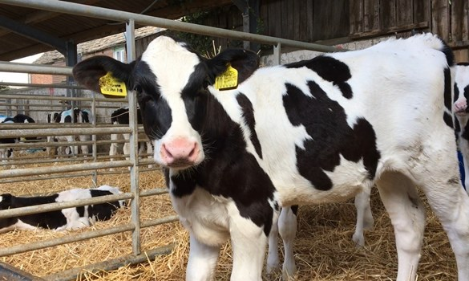

Managing the performance of team members

The John Adair model requires you to focus on three parts of any task in order to achieve success;

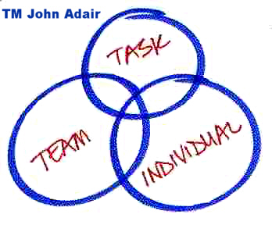

It is very important to manage all three parts, but the focus in this workbook will be on the Individual. It is vital that any task has clear SMART objectives so that achievement can be measured and celebrated.

What do you need to think about when managing each individual in your team?

|  |
| --- |
| 1………………………………………………………………………………………………………………………………………….  2………………………………………………………………………………………………………………………………………….  3………………………………………………………………………………………………………………………………………….  4…………………………………………………………………………………………………………………………………………. |

Some examples might be;

* understand the team members as individuals - personality, skills, strengths, needs, aims and fears
* assist and support individuals - plans, problems, challenges, highs and lows
* identify and agree appropriate individual responsibilities and objectives
* give recognition and praise to individuals - acknowledge effort and good work
* where appropriate reward individuals with extra responsibility, advancement and status
* identify, develop and utilise each individual's capabilities and strengths
* train and develop individual team members
* develop individual freedom and authority. Especially when working in a fairly isolated setting

You also need to consider, and communicate performance standards or service level agreements for your team, which need to be managed in conjunction with the SMART objectives.

These might be a general requirement to deal with a Customer query within 4 hours for example.

Write 2 SMART objectives which could be applied to an individual in your team or for yourself;

|  |
| --- |
| 1………………………………………………………………………………………………………………………………………….  ………………………………………………………………………………………………………………………………………….  2………………………………………………………………………………………………………………………………………….  …………………………………………………………………………………………………………………………………………. |

Think about how you are going to present these to the individual and to the team to facilitate ownership of them.

This is where MOTIVATION becomes critical, as a motivated individual will want to achieve their objectives.

INTRINSIC Motivation is within your control and refers to psychological rewards such as achieving, appreciation, positive recognition and being given the opportunity to use one’s ability. These psychological rewards can usually be determined by the actions and behaviour of individual managers.

EXTRINSIC Motivators are often determined at an organisation level, and include tangible results such as salary, promotion, working conditions and fringe benefits.

Think about how you reward team members who meet their objectives, bearing in mind their individual motivators.

Personal development, which can be in the form of training(T), coaching(C) or mentoring(M) can be very motivational and improve performance and therefore productivity as well.

Think of how you can incorporate some teaching and mentoring into your team building process.

|  |  |  |
| --- | --- | --- |
| Task | Method T/M/C | Resource needed |
|  |  |  |
|  |  |  |
|  |  |  |
|  |  |  |

Delegating tasks to team members can be very rewarding for them, and, when well supported, can help them develop and grow as individuals. It empowers team members which hopefully will give you more time to do other tasks. However delegation needs to be carried out in such a way that people don’t feel ‘dumped on’!



True EMPOWERMENT is the AUTHORISATION and the POWER to act

How would you go about delegating to a staff member?

|  |
| --- |
| 1………………………………………………………………………………………………………………………………………….  2………………………………………………………………………………………………………………………………………….  3………………………………………………………………………………………………………………………………………….  4………………………………………………………………………………………………………………………………………….  5………………………………………………………………………………………………………………………………………….  6………………………………………………………………………………………………………………………………………….  7………………………………………………………………………………………………………………………………………….  8………………………………………………………………………………………………………………………………………….  9…………………………………………………………………………………………………………………………………………. |

* Decide what to delegate
* Decide who to delegate to
* Explain what needs to be done and why
* Discuss how to do it
* Establish the operating parameters
* Agree monitoring methods
* Check understanding
* Help by being available
* Don’t interfere

Think of some of the tasks you do and who you can delegate them to. What extra support might they need?

|  |  |  |
| --- | --- | --- |
| Task | Person | Support needed |
|  |  |  |
|  |  |  |
|  |  |  |
|  |  |  |

An essential part of your role as a team leader is to monitor tasks that are being carried out, and give feedback.

“Feedback stimulates a positive, development-orientated process that leads over time, to learning, behaviour change and performance improvement”

Many informal and formal feedback events over time

Feedback shouldn’t be seen as a “one off” event…

**Continuous improvements in performance**

…but rather part of long term performance management

How can you monitor the activity being carried out?

|  |  |
| --- | --- |
| Activity | Monitoring action |
|  |  |
|  |  |
|  |  |
|  |  |

Remember to praise as much as possible when objectives are being met and good progress is being made. Sincere praise and gratitude are key motivators and mean a lot to team members, but honest feedback is an essential part of being a team leader.

This might need to be followed by development plans where necessary. Developing staff starts with a meaningful and effective Appraisal Scheme.

Appraising staff is a more formal process than the regular 1-1 meetings you will be having with them, to consider their aspirations, their development needs, how these align with business objectives, then setting a well-defined Personal Development Plan with clear SMART objectives.

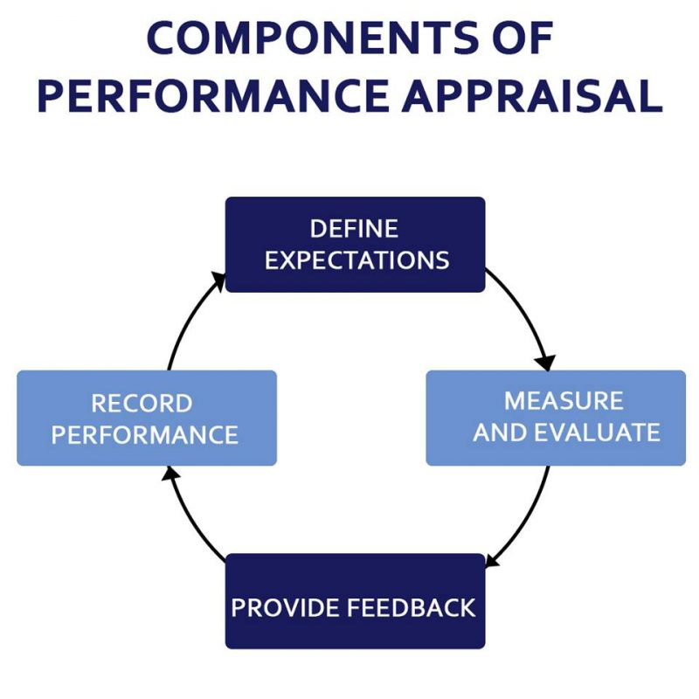businesstopia.net

The Appraisal Process

The appraisal process should be another very motivational process for team members where they have quality 1-1 time with their Manager to actually consider their career progression. Communication is key, and the more you understand the aspirations of the team member the more you can help them achieve their goals.

What do you think are the positive and challenging sides of carrying out appraisals?

|  |  |
| --- | --- |
| Positive outcomes | Challenges |
|  |  |
|  |  |
|  |  |
|  |  |
|  |  |

Developing people can be carried out in a variety of ways. Think of three ways you have done personal development activities over the years. What have been the advantages and disadvantages?

|  |  |  |
| --- | --- | --- |
| Development activity | Advantage | Disadvantage |
|  |  |  |
|  |  |  |
|  |  |  |
|  |  |  |

The appraisal process is all about setting SMART objectives across the organisation which should align with the defined Critical Success Factors (CSF’s). Typically the Senior Management Team sets these and produces Key Performance Indicators (KPI’s) to enable them to be met (top down appraisal).

SMART objectives are then set during each team member’s appraisal to ensure the KPI’s and hence the CSF’s are met.

Other forms of appraisal include;

* Self Appraisal, where team members evaluate their own performance
* Peer Review Process, where team members review each others performance
* 360° appraisal where team members also appraise their team leaders and Managers.

The usual form of appraisal is a top down approach, and is an opportunity for Managers to evaluate each persons performance against their SMART objectives, and to have a candid conversation around what has gone well in the previous 6 months or year, and even better if…

This is a good forum for Managers to understand the strengths a person can offer, their aspirations and any development needs to achieve these. It is also an opportunity to discuss what has not gone quite so well, and any development needs to address this.

The end result should be a document with the SMART objectives for the next year, an action plan for development opportunities and a career plan as a basis for ongoing development. Ideally a Manager can celebrate success with the team member and offer sincere appreciation for work well done.

However this is also a forum to discuss shortfalls in performance, although there should be no surprises for the team member; as mentioned earlier giving feedback should be a continuous process, not saved for the annual appraisal.

If you work alone could anyone else help you to objectively evaluate your performance? It is a useful exercise to do but difficult to do on yourself!

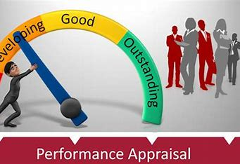

As with any worthwhile task, Proper Preparation Prevents Poor Performance!

Prepare for each appraisal interview carefully to maximise the use of the time available. For each team member prepare some specific questions, and have examples to illustrate what you are saying, both for positive feedback and to challenge behaviours. Remember to ask open questions (Who? What? Why? Where? When? How?), and let them do 80% of the talking.

What preparations do you need to make before the appraisal interview?

|  |
| --- |
| 1………………………………………………………………………………………………………………………………………….  2………………………………………………………………………………………………………………………………………….  3………………………………………………………………………………………………………………………………………….  4………………………………………………………………………………………………………………………………………….  5………………………………………………………………………………………………………………………………………….  6………………………………………………………………………………………………………………………………………….  7…………………………………………………………………………………………………………………………………………. |

Think about the logistics, where and when for example, and book the time as ‘Do not disturb’.

Read previous appraisal paperwork to see the objectives set. Have they been met? Have examples to use for praise or to promote difficult discussion.

If the situation becomes emotional take a 10 minute break and then reconvene.

Think about the sort of parameters you would like to discuss with your team member; frame an open question about each one. For example if challenging lateness, have evidence of how many times the team member has been late in the last month and ask how they think this affects the team overall, as well as trying to understand why this is happening.

|  |  |
| --- | --- |
| Parameter or behaviour | Open question to probe further |
|  |  |
|  |  |
|  |  |
|  |  |
|  |  |

Having set the SMART objectives for the coming year, prepare an action plan, or personal development plan, to provide guidance on how progress might be achieved. This should include a SMART objective, for example ‘Achieve your sprayer certificate within the next 6 months’ and a plan of how this might be achieved (attend a course at the local Agricultural College). Put the intended achievement date and also a review date in case there is some slippage in time frames.

When the objective has been achieved it can be signed off and another objective set.

It is a good idea for everyone to do a personal SWOT analysis;

* Strengths,
* Weaknesses,
* Opportunities,
* Threats.

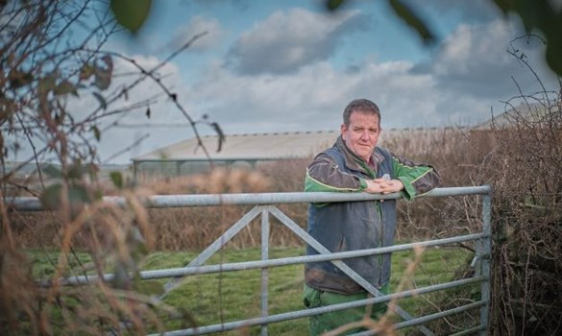

Fill this in honestly for yourself; this is even more important if you work alone!

|  |  |
| --- | --- |
| **STRENGTHS**  What are your strengths?  What do you do well?  What should you do more of? | **WEAKNESSES**  What are you not so good at?  What would you like to do less of?  Why? |
| **OPPORTUNITIES**  Where do you see yourself in the short/medium/longer term?  What do you think will help you to achieve this?  What other possible opportunities are there for you? | **THREATS**  What is stopping you achieving your aims?  Why is this happening?  How can it be changed? |

Use the information to inform your Personal Development Plan (PDP) and your appraisal objectives. Everyone should have a dynamic PDP; start yours now if you don’t already have one;

|  |  |  |  |
| --- | --- | --- | --- |
| SMART objective to achieve | HOW will I achieve it? | Date to achieve by | Review date |
|  |  |  |  |
|  |  |  |  |
|  |  |  |  |
|  |  |  |  |
|  |  |  |  |

This document should form an important part of your personal development strategy, and after your appraisal should be reviewed regularly to ensure progress against objectives is being made.

Ideally you will have 1-1 meetings with your Manager at least monthly to review your progress against objectives and identify any extra help or resource you might need to achieve them.

If you work alone do try and be disciplined enough to set yourself targets and think about how you can continue your own professional development, both for your own motivation and for the continued success of your farm or nursery.

Ideally your organisation will have Policies and Procedures around how you conduct appraisals and it is important you are aware of these and follow them at all times,

Developing your staff

Continuous Professional Development(CPD) is vital when there is so much change to navigate for farmers and growers.

Staff that are offered development opportunities are more motivated and more productive than those who aren’t, and this also affords you the chance for succession planning activities to ensure people are available to undertake roles should key staff either leave or be absent (either planned or unplanned).

New experiences are an excellent way of keeping teams engaged with their role, and visiting other farmers or growers always involves conversations around how and why things are done the way they are, enabling processes to be challenged. This is especially important for lone workers, as they can become very set in their ways.

There are several ways of learning, and these can be formal or informal. Think about the advantages and disadvantages of each;

|  |  |  |
| --- | --- | --- |
| Type of learning | Advantages | Disadvantages |
| Formal |  |  |
| Informal |  |  |
| Self teaching (reading books/videos) |  |  |
| Online |  |  |
| Experiential (role plays or project work) |  |  |

Learning on the job is a favoured option as it is inexpensive, easy to organise, flexible, and can develop both the trainer and the learner. However it may also pass on bad habits, may stop a skilled worker being very productive, and may not be seen as true ‘training’.

The other option of a formal course often carries the opportunity for a qualification to be gained, and is carried out against a standardised syllabus. However it may be perceived as expensive, long winded and inconvenient.

Self teaching relies on the learner being motivated enough to carry it out, and some may not challenge themselves sufficiently.

E-learning is convenient and accessible to most people, especially if done in the workplace, but it may not relate directly to the organisation, and for practical applications it is very limited.

Experiential learning can be fun as it can be based on real life scenarios and simulations, but can be time consuming and some people find it threatening to perform in front of their peers.

The final choice depends on the individuals’ preferences, finances, time available, and the suitability and locality of courses in often rural areas.

Thinking about yourself, think of three tasks you would like to be more proficient in and identify the options of how you can achieve this, identifying the advantages and disadvantages of each;

|  |  |  |  |
| --- | --- | --- | --- |
| Task | Method | Advantages | Disadvantages |
|  |  |  |  |
|  |  |  |  |
|  |  |  |  |

Now do the same exercise for a team member;

|  |  |  |  |
| --- | --- | --- | --- |
| Task | Method | Advantages | Disadvantages |
|  |  |  |  |
|  |  |  |  |
|  |  |  |  |

Coaching and mentoring are two very useful ways of supporting development within a team.

Coaching is holding up a mirror to the learner and challenging, stretching and supporting them.

Mentoring is supporting them through their learning and acting as an additional resource while they apply new methodologies in the workplace.

Delegating is also a form of development, as long as it is done in a structured manner with sufficient support offered.

Think of opportunities you might have for each of them;

|  |  |
| --- | --- |
| Method | Opportunity to put into practice |
| Coaching |  |
| Mentoring |  |
| Delegation |  |

What do you think are the advantages and disadvantages of each?

|  |  |  |
| --- | --- | --- |
| Method | Advantages | Disadvantages |
| Coaching |  |  |
| Mentoring |  |  |
| Delegation |  |  |

Training and development activity is determined by Policies and Procedures and a budget set for the activity through the year on a departmental basis where appropriate. These should identify support and resources available for workforce development.

If you are a smaller farmer or grower there are excellent resources on the AHDB website which are specifically aimed at you.

What resources are available in your organisation or regionally to enable or support team members through their CPD?

|  |
| --- |
| 1………………………………………………………………………………………………………………………………………….  2………………………………………………………………………………………………………………………………………….  3………………………………………………………………………………………………………………………………………….  4…………………………………………………………………………………………………………………………………………. |

As can be seen from the dynamic development plan, learning is a cycle and there should be constant evaluation of the effectiveness of the experience in order to think about the next opportunity. In the most effective organisations staff development is a vital precursor to their success.

Evaluating the effectiveness of the CPD will also form part of the discussion at the appraisal;

* How does the team member feel about the experience?
* What did they actually learn?
* How will it help them to be more effective?
* What other opportunities do they need to further their development?

Think about a development experience you have taken in the last 6 months and answer the questions for yourself;

|  |  |
| --- | --- |
| Experience; | When undertaken; |
| How did you feel about the experience? |  |
| What did you actually learn? |  |
| How will it help you to be more effective? |  |
| What other opportunities for development would you like? |  |

Remember to always be realistic about development opportunities on offer; don’t promise everyone everything they ask for as it will be de-motivational if they are not offered something they were promised. Try and be creative and think of achievable ways of carrying out the learning.

Whilst appraisals are typically carried out annually, and ideally 1-1 meetings will happen monthly, some organisations carry out a half yearly review to check progress and offer any additional support needed to ensure the objectives are met.

This has been very neatly summarised on the AHDB website; [Managing and motivating people | AHDB](https://ahdb.org.uk/farm-excellence/houghton-lodge-farm/managing-and-motivating-people)

* Ensure you establish your business vision, where you want to be, and what your ambitions are
* Consider how you clearly communicate your vision and plan to your team and take time to get their input if possible
* Plan how you will achieve your ambitions, determining what everyone’s role and purpose will be in working towards these goals
* Never underestimate the importance of taking time to better understand your staff, find out what they enjoy and what motivates them.
* Some of the best teams enjoy their role and share fun and laughter during their working days
* The little things can make a big difference - thank you, please and commending good work are all key
* We are all responsible for creating and managing our work environments and atmosphere for our staff and teams

All pictures in this workbook have been taken from the AHDB website.